Boston University

Electrical & Computer Engineering

EC463 Senior Design Project

**First Prototype Testing Plan**

***SharkCam***

## 

## 

## 

## by

Team 28

SharkCam

Team Members

Liron Dubin (ME)

Brett Senders (ME)

Kevin Vasquez (ME)

Sophia Delia (CE)

Alex Hureaux-Perron (EE/CE)

## 

## Testing Goals:

1. Test local network connection to robot using router as access point
2. Test Robopad commands
   1. Clean
   2. Pause clean
   3. Joystick movement
3. Test collision detection routine
4. Test web app menu navigation

## Required Materials

Hardware:

* Laptop
* Shark Robot
* GL-MT300N-V2 Router
* Camera Column Base
* PVC Camera Column

Software:

* SharkClean app
* Web browser
* RoboPad testing interface
* Prototype web app

## Testing Overview

The general testing campaign is divided into two parts: 1: moving the robot to test our proposed collision detection routine, and 2: testing the navigation functionality of the prototype companion web app. We will use RoboPad, the robot’s testing interface to manually control the robot by sending commands directly to the motor controllers, and to trigger the robot’s autonomous cleaning mode. While the robot can broadcast an IP address, we have decided to use our own router in order to create a network environment we can control, and because the final prototype will rely on an external network. The manual commands sent using Robpad will exactly simulate the manual commands sent over the network by our custom web app in the final prototype.

A key operating subroutine of our robot is to detect when the camera column has collided with an obstacle, stop the robot, and move it away from the obstacle. The purpose of this test is to verify that this obstacle avoidance routine will function without the robot losing track of its absolute location within its mapped area. Because manually commands bypass the robot’s standard control systems, there is a possibility that the robot will have to re-establish its location before it can resume autonomous navigation.

## Testing Procedure

### Network Connection (Setup)

1. Power on router
2. Put robot into network connection mode
3. Use SharkClean app to connect robot to local network
4. On laptop, use web browser to navigate to router’s admin interface
   1. Find robot’s IP by verifying MAC address
5. Navigate to robot’s IP address followed by port 8080
   1. xxx.xxx.xx:8080
6. Check that Robopad interface successfully loads

### Robopad

1. Test motor commands
2. Test clean command

### Collision Detection Routine

1. Start clean mode
2. Let robot move away from base
3. Pause clean mode
4. Use joystick interface to move robot manually
5. Resume cleaning mode
6. Observe behavior

### Web App Functionality

1. Use Flask to serve main, photo view, and robot control web pages
2. Call start, stop functions using appropriate buttons on control page
3. Observe behavior - appropriate messages should appear on webpage

## Measurable Criteria

* The robot should successfully connect to the router’s network.
* The RoboPad interface should load in the web browser.
* The robot should respond to commands sent using RoboPad. On RoboPad, there are inputs to change speeds of various motors. There should be a noticeable difference between different speeds when selected. Additionally, the robot should respond to commands sent using joystick control.
* The robot should reorient in relation to the mapped area when cleaning mode is resumed following manual commands sent by over RoboPad.

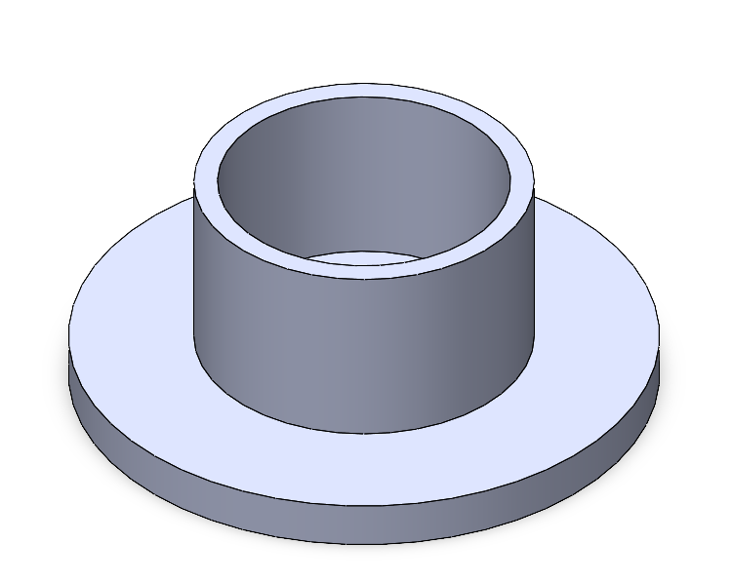

Figure 1: Base mount for column

## Results

## *Test date: 11/15/22*

* The robot successfully connected to the router’s network
* Robopad successfully sent commands to the robot
* The robot resumed autonomous cleaning without entering an error state or needing to re-orient (confirmed by viewing live location on Robopad)
* The prototype web app front end navigation works without error